**Drink Service**

Introducing our newest product, the Drink Service. This system is made for bars and restaurants that serve alcoholic beverages of any kind. We have designed this product to be user friendly and secure from the ground up. Unlike most other management systems on the market this system uses on prem storage instead of expense servers or SaaS subscriptions. We are excited to take you through our new product!

**Downloading**

This product can be downloaded off our website. Navigate over to our homepage for more information about our company and the products we build. This product will be under Project 1. Along with simple instructions on how to use our product there is a download link where you can download with only one click! It is important to know even though this product is free we preserve the right to distribute and change the product as we see fit and we may charge for the product in the future. This application is transmitted through an .exe file but during download it may distribute as a .zip file that you will need to unzip.

**Technical Application Details**

This project was use build using python3 exclusively. The apps three core functionalities are to store, forward, and search datasets. The UI of this application was developed using the tkinter library utilizing the most current design patterns. The main storage containers of this application are lists, dictionaries, and json files for the most efficient and fast experience for our users. This application stores a set number of attributes including attributes pertaining to drinks, employee data, ingredient data, and logs for internal use.

**Legal**

User input is filtered for compliance so the input you enter into the system may change due to filtering. Before using the application, every user must accept the user agreement. Whoever does not agree with the user agreement will not be allowed to use the app. The user agreement is as follows “If you press agree, you give consent to the use of data you provide to be used in any way the company sees fit. If you have any questions are concerns, please contact HR. Any data that is given is at will and we are not responsible for security breaches. user may not sell or distribute data without the express consent of umbrella company. This program goes through routine data penetration tests but unauthorized tests or uses is prohibited. These requirements are elastic and may change over time as needed.” As stated above we do routine security checks, but we are not liable for any security breaches while using the product. As with application all these implications are subject to change.

**Where this Application is Going**

As we add new features to this application, we would like to create a roadmap of where we are going. Our first step would be greater security for administrators and giving them more capabilities like deleting records (Which can be done from the json file but not from the UI. From there we would like to work on a better UI due to the limitations of tkinter our application is not in a UX space we would like it to be in. Improvements like modern web design patterns and graphics are necessary. Lastly, we would like to add a cloud implementation making this more of a desktop web application utilizing AWS. Along with the web implication we would be able to reimplement the UI using Material Design patterns and use Electron for build the web app.

**User Guide (Step by Step)**

Step 1: User Agreement

* If you deny the application will automatically close and you will not be able to continue until you accept.

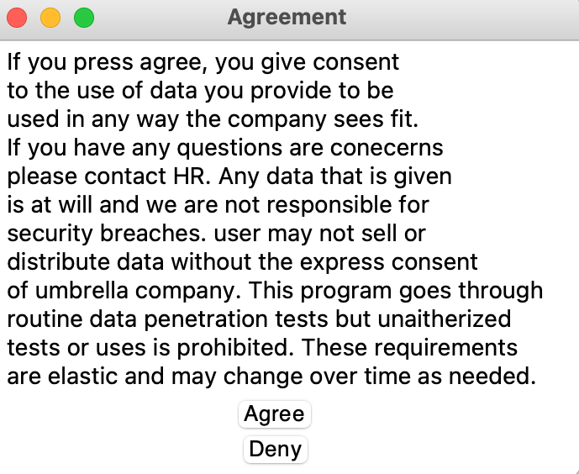

Step 2: Main Control

* Main control is super simple just select either a drink to take action on or select “More Options”

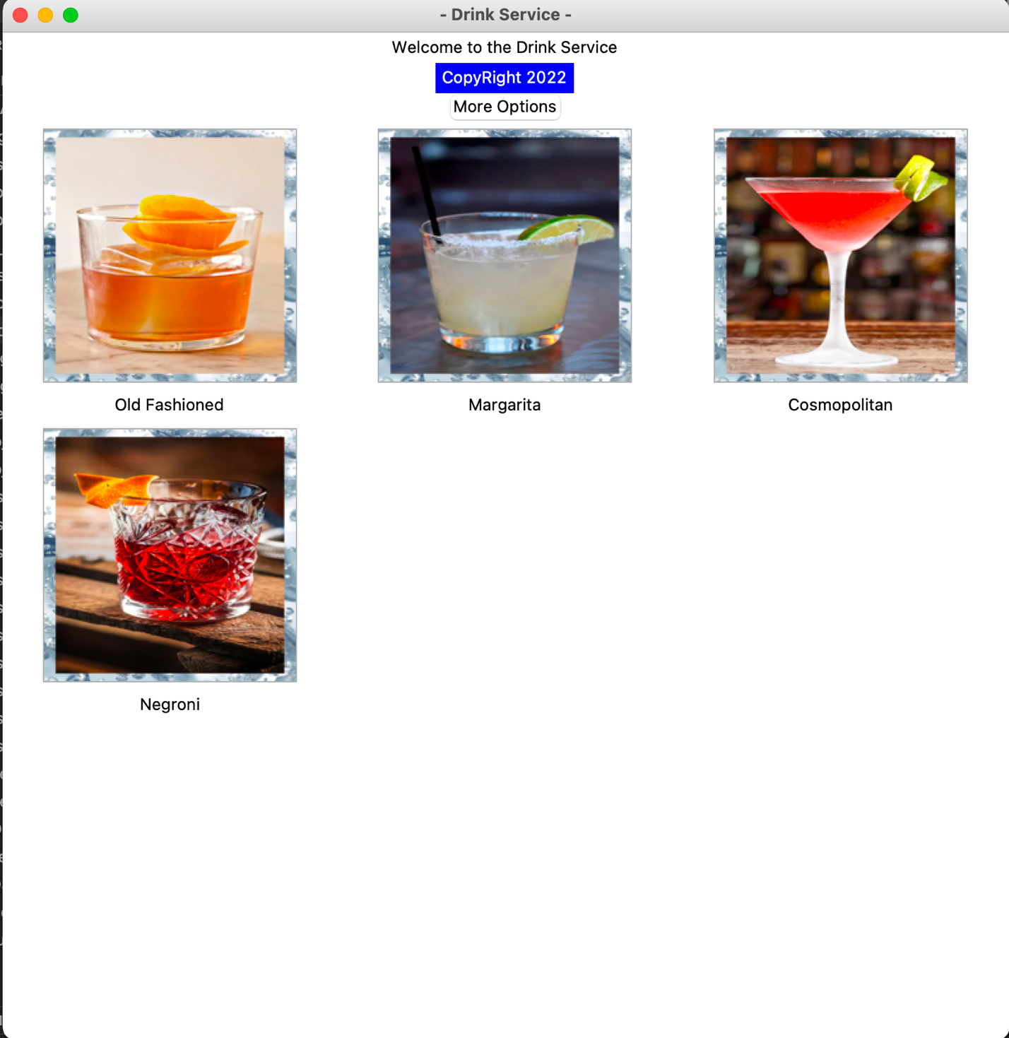

Step 3: Taking actions

* You will be brought to this login screen. For all the buttons except Drink details you need to be logged in.

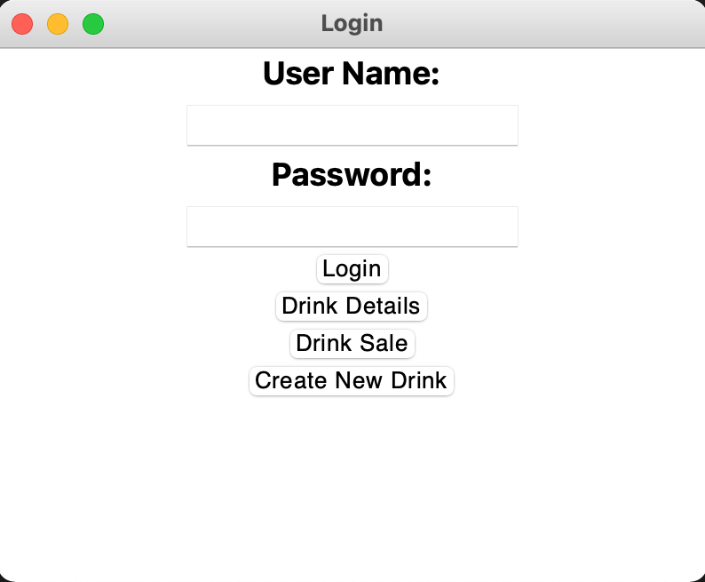

* Drink Details: Will bring up the Details of the currently selected drink.

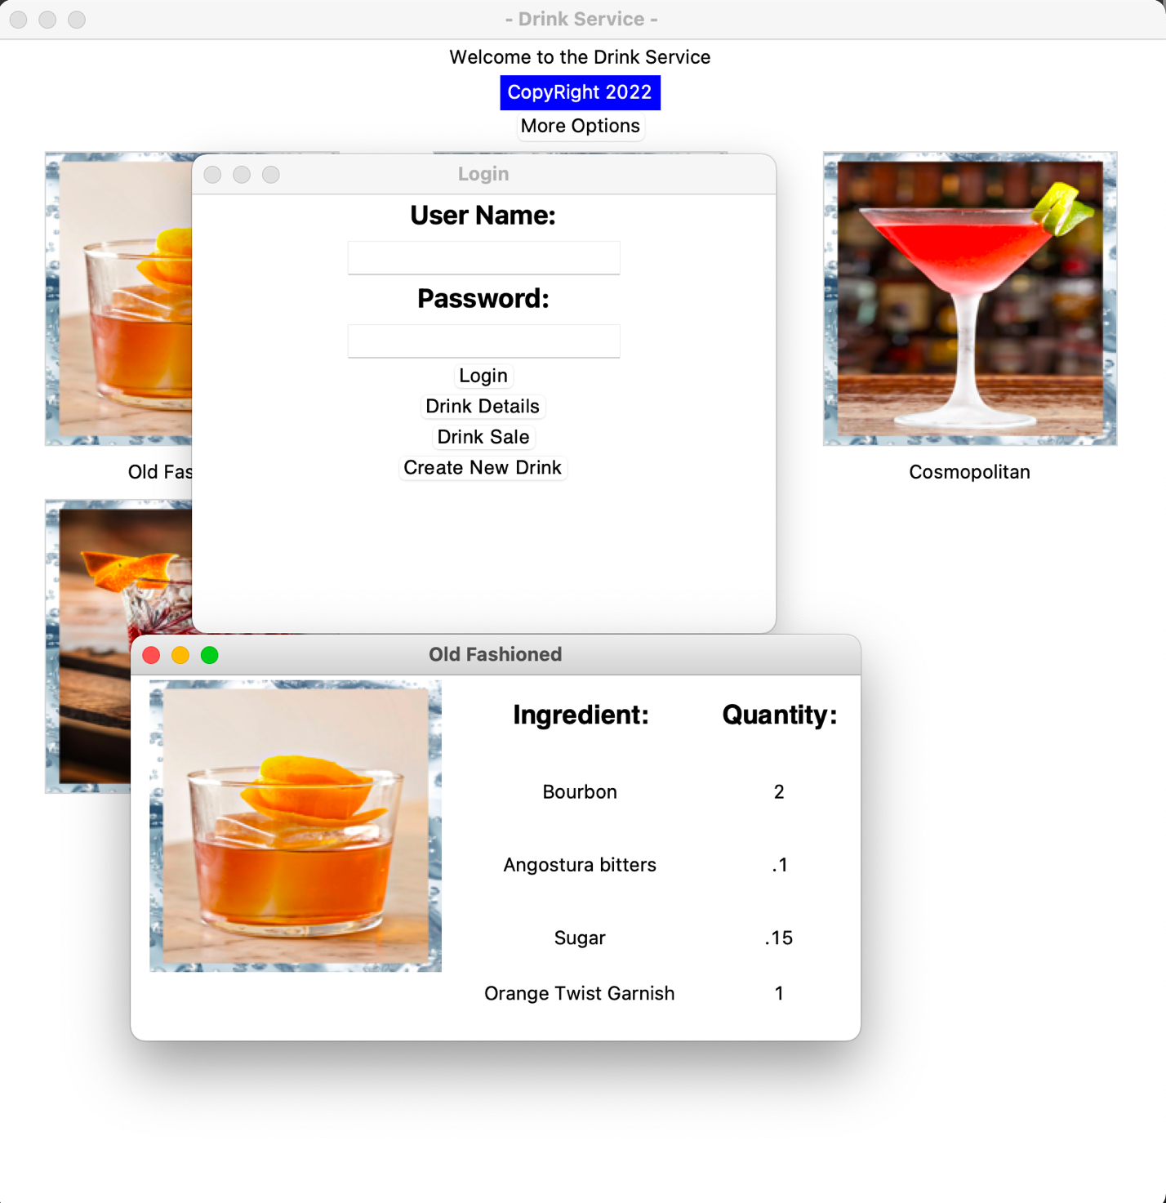

* If you select anything but drink details without logging in it will create a pop up.

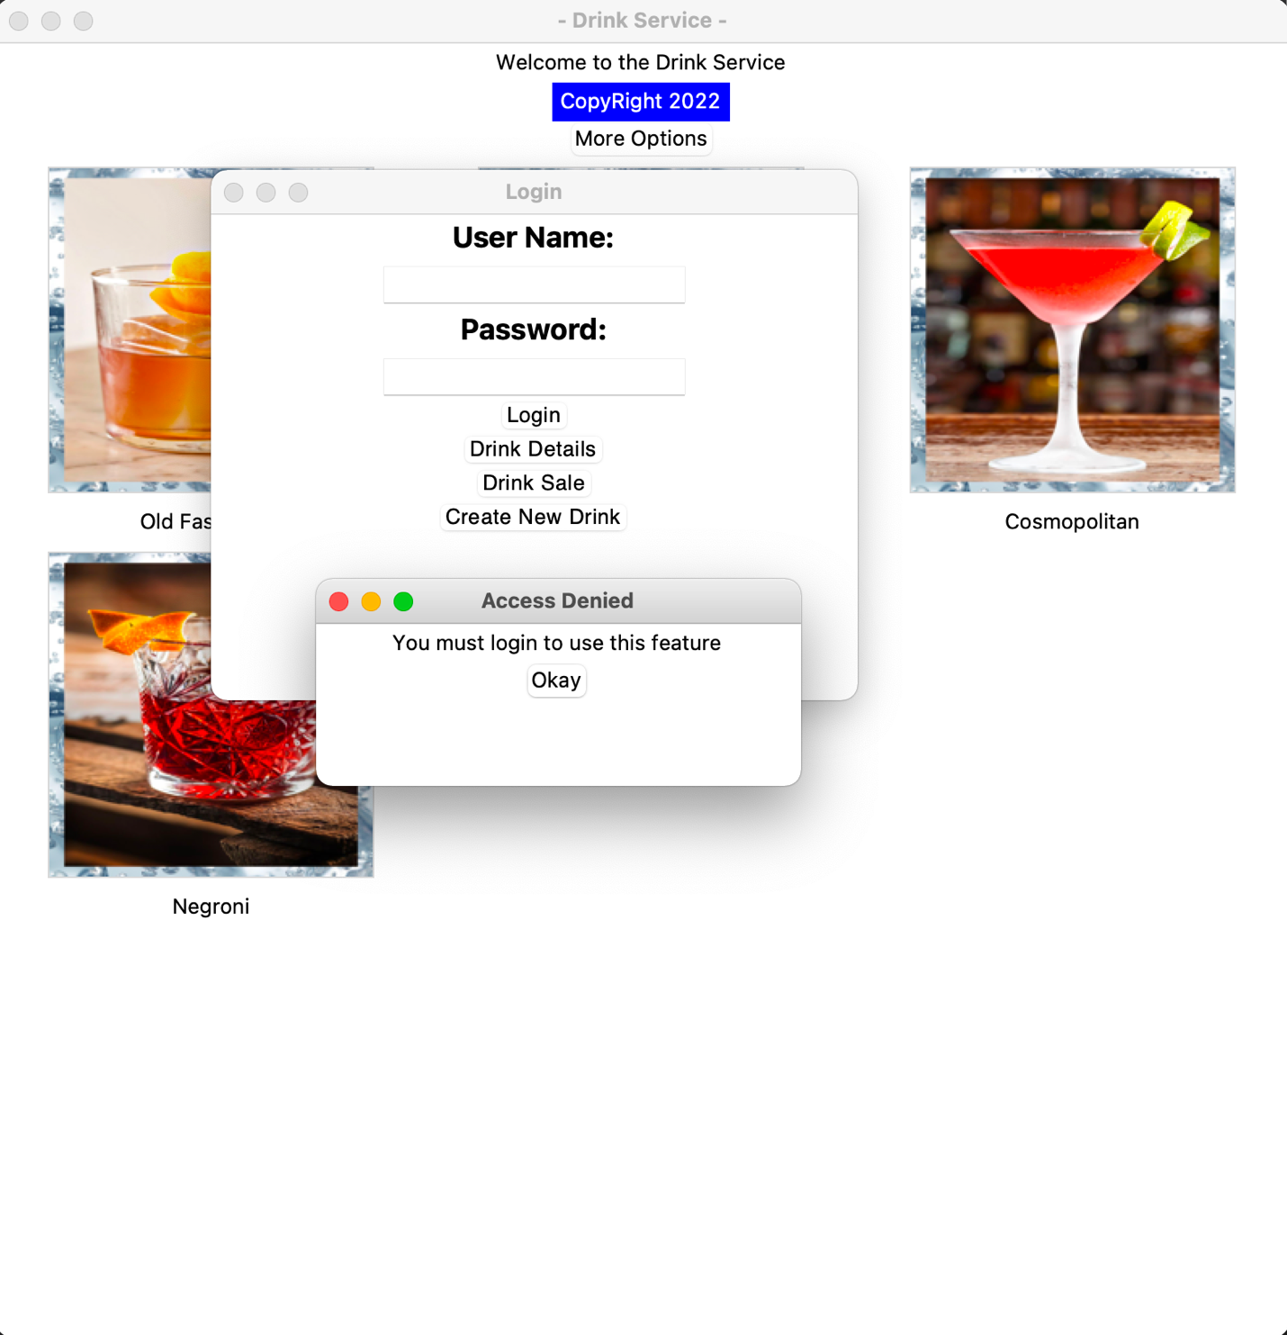

* Logging in is as simple as putting in your username and password

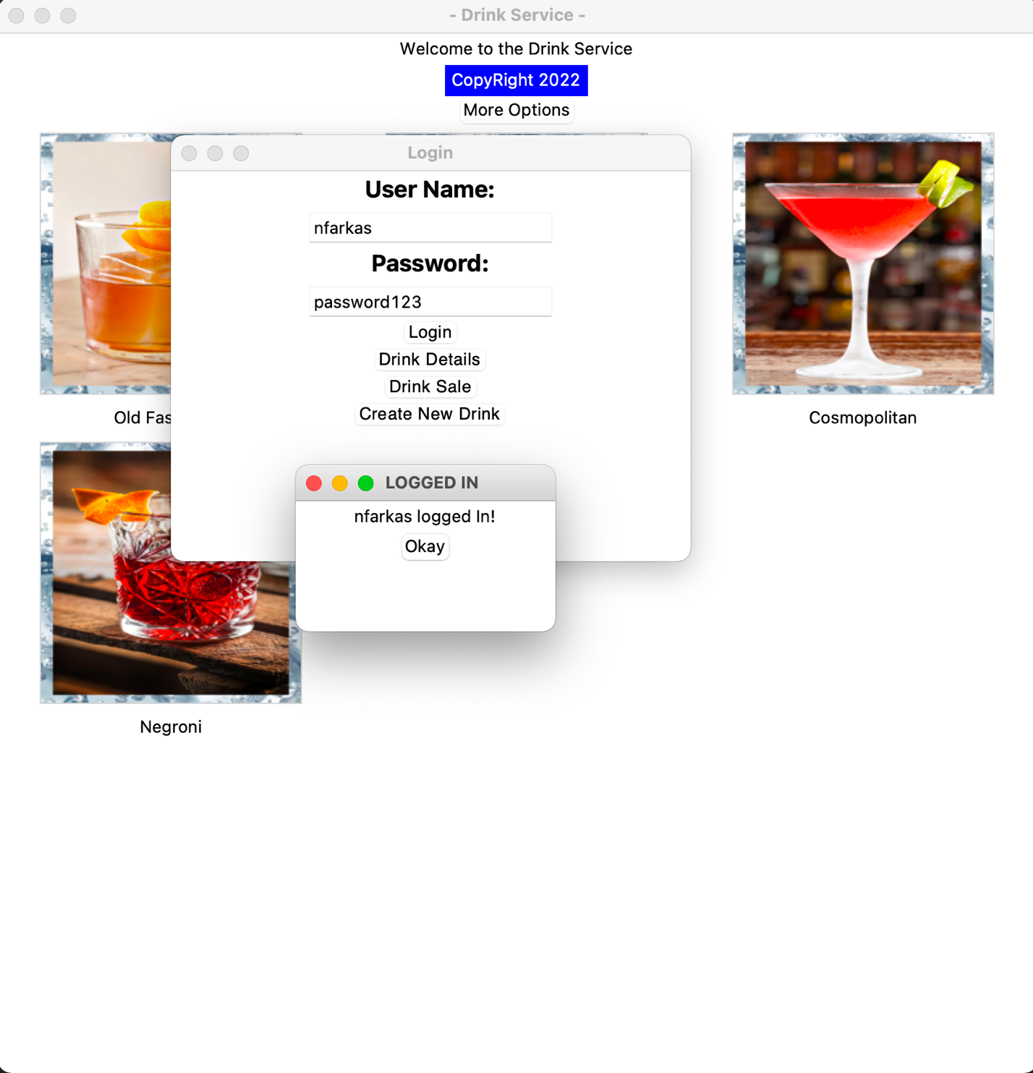

Step 4: Creating a new Drink

* Data fields may be left blank but there are some requirements. Fields must abide by no special characters.

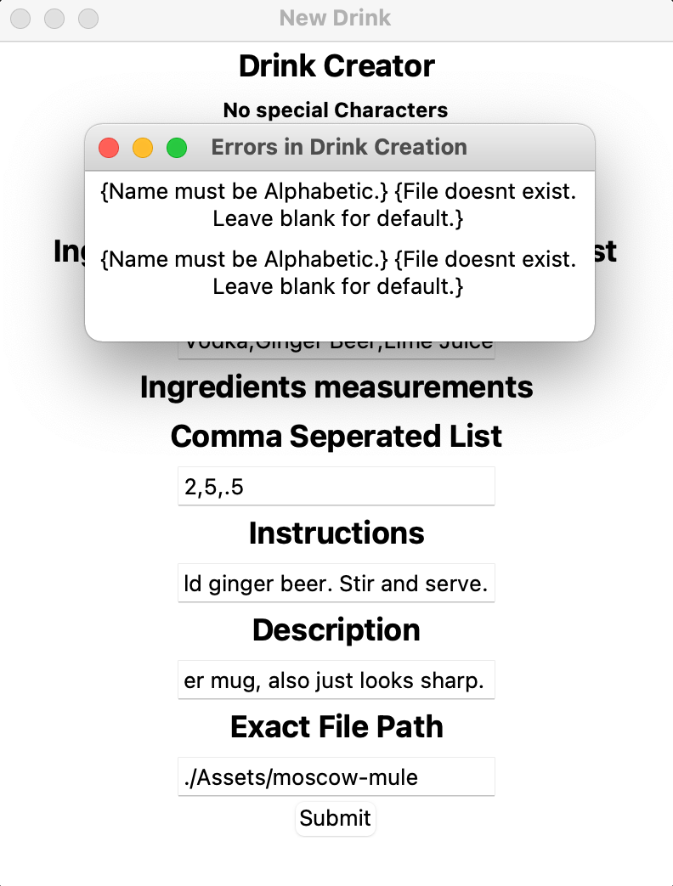

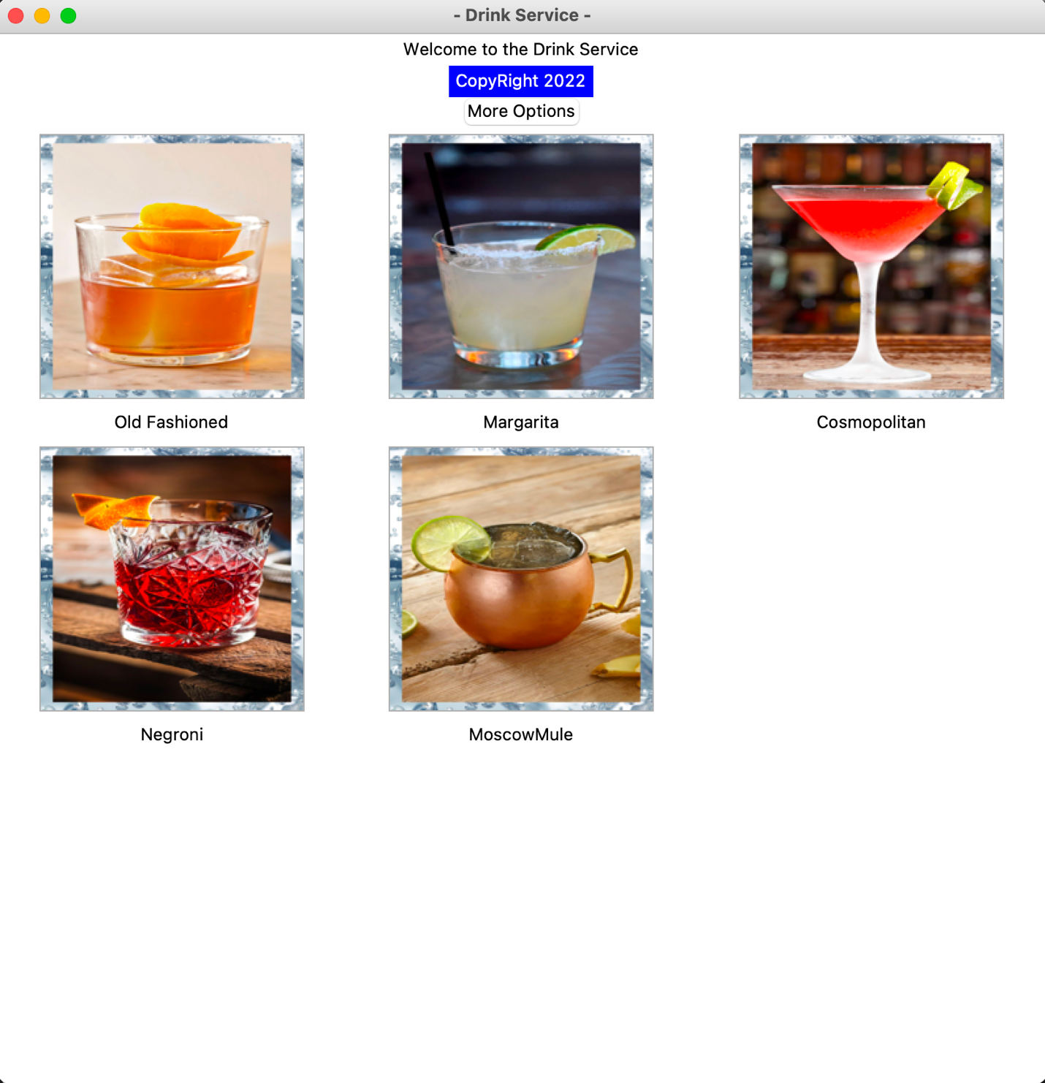

**Flow Diagram**

